1. Find a house through Realtor.com

<https://www.realtor.ca/Residential/Single-Family/18020478/114-Rue-des-%C3%89glantiers-Hull-Gatineau-Quebec-J8Y6R7-Mont-Bleu>

1. Calculate the borrowing costs; Chose a closed, fixed rate for a 5 year term, and determine your amortization or use 25 years.

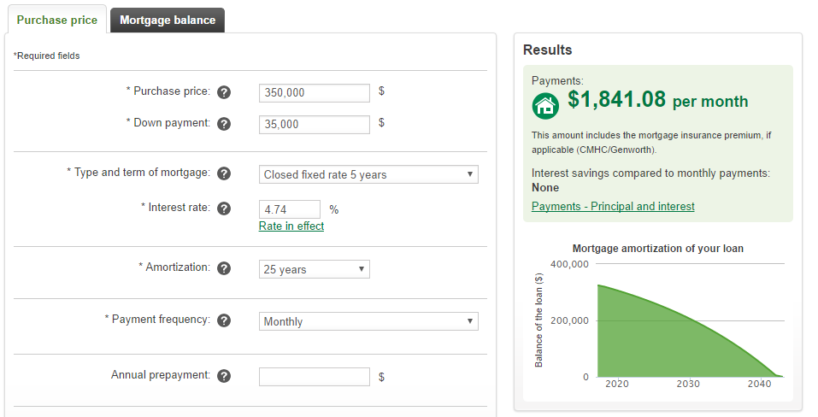

1. Calculate the down payment

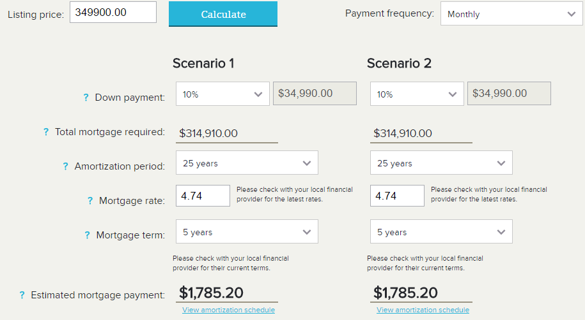

1. When do you want to buy? Calculate how much you will need to save for your down payment

I would like to buy a house when I’m around 30, which will be in 12 years. I want to spend time before then travelling and working different jobs and getting interesting job experience, then I think after doing that for a while I would want to settle down and buy a house. If I start saving now, I would have to save another 29000$ for the down payment of the house, which wouldn’t take too long once I start working. I want to make myself financially stable before I move out, so I’d be able to save a lot, then move out to rent an apartment while saving for a house.